Backtracking:
In this topic, we will learn about the backtracking, which is a very important skill set to solve recursive solutions. Recursive functions are those that calls itself more than once. Consider an example of Palindrome:
Initially, the function isPalindrome(S, 0, 8) is called once with the parameters isPalindrome(S, 1, 7). The recursive call isPalindrome(S, 1, 7) is called once with the parameters isPalindrome(S, 2, 6).
Backtracking is one of the techniques that can be used to solve the problem. We can write the algorithm using this strategy. It uses the Brute force search to solve the problem, and the brute force search says that for the given problem, we try to make all the possible solutions and pick out the best solution from all the desired solutions. This rule is also followed in dynamic programming, but dynamic programming is used for solving optimization problems. In contrast, backtracking is not used in solving optimization problems. Backtracking is used when we have multiple solutions, and we require all those solutions.
Backtracking name itself suggests that we are going back and coming forward; if it satisfies the condition, then return success, else we go back again. It is used to solve a problem in which a sequence of objects is chosen from a specified set so that the sequence satisfies some criteria.

When to use a Backtracking algorithm?
When we have multiple choices, then we make the decisions from the available choices. In the following cases, we need to use the backtracking algorithm:
- A piece of sufficient information is not available to make the best choice, so we use the backtracking strategy to try out all the possible solutions.
- Each decision leads to a new set of choices. Then again, we backtrack to make new decisions. In this case, we need to use the backtracking strategy.

How does Backtracking work?
Backtracking is a systematic method of trying out various sequences of decisions until you find out that works. Let's understand through an example.
We start with a start node. First, we move to node A. Since it is not a feasible solution so we move to the next node, i.e., B. B is also not a feasible solution, and it is a dead-end so we backtrack from node B to node A.
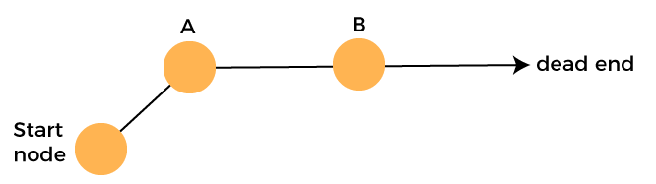
Suppose another path exists from node A to node C. So, we move from node A to node C. It is also a dead-end, so again backtrack from node C to node A. We move from node A to the starting node.
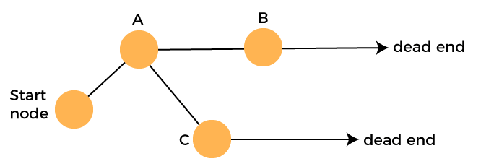
Now we will check any other path exists from the starting node. So, we move from start node to the node D. Since it is not a feasible solution so we move from node D to node E. The node E is also not a feasible solution. It is a dead end so we backtrack from node E to node D.
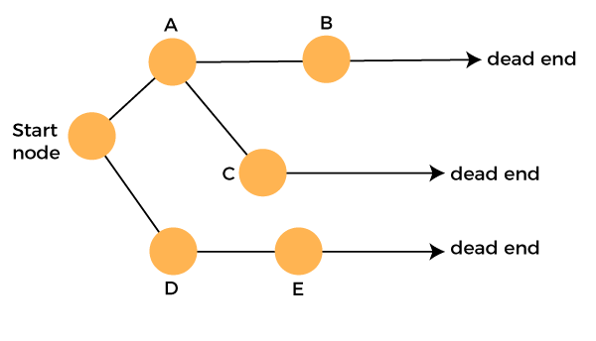
Suppose another path exists from node D to node F. So, we move from node D to node F. Since it is not a feasible solution and it's a dead-end, we check for another path from node F.
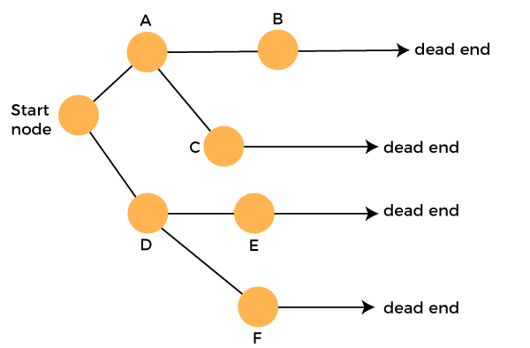
Suppose there is another path exists from the node F to node G so move from node F to node G. The node G is a success node.
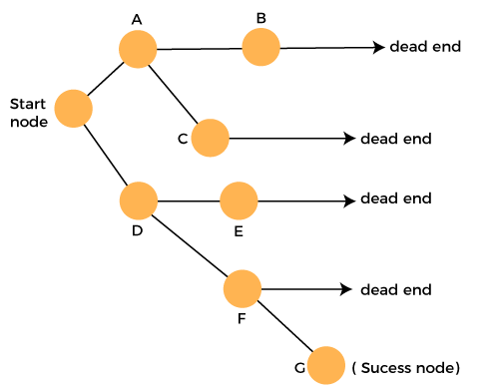
The terms related to the backtracking are:
- Live node: The nodes that can be further generated are known as live nodes.
- E node: The nodes whose children are being generated and become a success node.
- Success node: The node is said to be a success node if it provides a feasible solution.
- Dead node: The node which cannot be further generated and also does not provide a feasible solution is known as a dead node.
Many problems can be solved by backtracking strategy, and that problems satisfy complex set of constraints, and these constraints are of two types:
- Implicit constraint: It is a rule in which how each element in a tuple is related.
- Explicit constraint: The rules that restrict each element to be chosen from the given set.

Applications of Backtracking
- N-queen problem
- Sum of subset problem
- Graph coloring
- Hamiliton cycle/circuit

Difference between the Backtracking and Recursion
Recursion is a technique that calls the same function again and again until you reach the base case. Backtracking is an algorithm that finds all the possible solutions and selects the desired solution from the given set of solutions.

Recursive Maze Algorithm
Recursive Maze Algorithm is one of the best examples for backtracking algorithms. Recursive Maze Algorithm is one of the possible solutions for solving the maze.

Maze
The maze is an area surrounded by walls; in between, we have a path from starting point to ending position. We have to start from the starting point and travel towards from ending point.
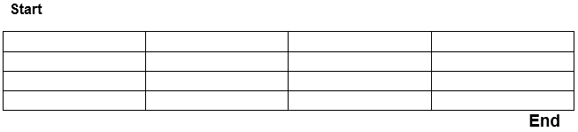

Principle of Maze
As explained above, in the maze we have to travel from starting point to ending point. The problem is to choose the path. If we find any dead-end before ending point, we have to backtrack and move the direction. The direction for traversing is North, East, West, and South. We have to continue "move and backtrack" until we reach the final point.
Consider that we are having a two-dimensional maze cell [WIDTH] [HEIGHT]. Here cell [x] [y] = 1 denotes wall and cell [x] [y] = 0 denotes free cell in the particular location x, y in the maze. The directions we can change in the array are North, East, West, and South. The first step is to make the boundary of the two - dimensional array as one so that we won't go out of the maze and usually reside inside the maze at any time.
Example Maze
1 | 1 | 1 | 1 | 1 | 1 | 1
1 | 0 | 0 | 0 | 1 | 1 | 1
1 | 1 | 1 | 0 | 1 | 1 | 1
1 | 1 | 1 | 0 | 0 | 0 | 1
1 | 1 | 1 | 1 | 1 | 0 | 1
1 | 1 | 1 | 1 | 1 | 1 | 1

Now start changing from the starting position (since the boundary is filled by 1) and find the next free cell then turn to the next free cell and so on. If we grasp a dead-end, we have to backtrack and make the cells in the path as 1 (wall). Continue the same process till the final point is reached.

Hamiltonian Circuit Problems
Given a graph G = (V, E) we have to find the Hamiltonian Circuit using Backtracking approach. We start our search from any arbitrary vertex say 'a.' This vertex 'a' becomes the root of our implicit tree. The first element of our partial solution is the first intermediate vertex of the Hamiltonian Cycle that is to be constructed. The next adjacent vertex is selected by alphabetical order. If at any stage any arbitrary vertex makes a cycle with any vertex other than vertex 'a' then we say that dead end is reached. In this case, we backtrack one step, and again the search begins by selecting another vertex and backtrack the element from the partial; solution must be removed. The search using backtracking is successful if a Hamiltonian Cycle is obtained.
Example: Consider a graph G = (V, E) shown in fig. we have to find a Hamiltonian circuit using Backtracking method.
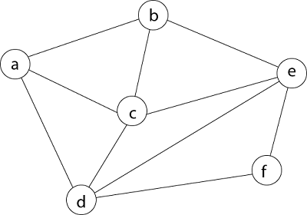
Solution: Firstly, we start our search with vertex 'a.' this vertex 'a' becomes the root of our implicit tree.
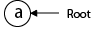
Next, we choose vertex 'b' adjacent to 'a' as it comes first in lexicographical order (b, c, d).
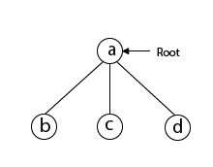
Next, we select 'c' adjacent to 'b.'
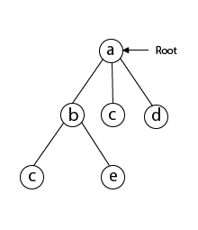
Next, we select 'd' adjacent to 'c.'
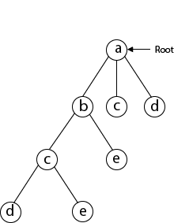
Next, we select 'e' adjacent to 'd.
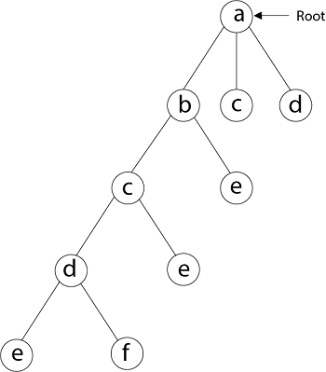
Next, we select vertex 'f' adjacent to 'e.' The vertex adjacent to 'f' is d and e, but they have already visited. Thus, we get the dead end, and we backtrack one step and remove the vertex 'f' from partial solution.
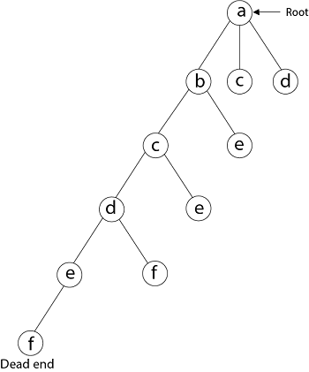
From backtracking, the vertex adjacent to 'e' is b, c, d, and f from which vertex 'f' has already been checked, and b, c, d have already visited. So, again we backtrack one step. Now, the vertex adjacent to d are e, f from which e has already been checked, and adjacent of 'f' are d and e. If 'e' vertex, revisited them we get a dead state. So again we backtrack one step.
Now, adjacent to c is 'e' and adjacent to 'e' is 'f' and adjacent to 'f' is 'd' and adjacent to 'd' is 'a.' Here, we get the Hamiltonian Cycle as all the vertex other than the start vertex 'a' is visited only once. (a - b - c - e - f -d - a).
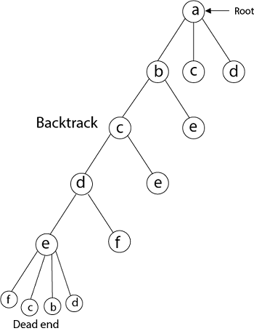
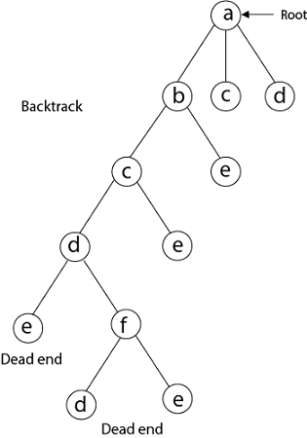
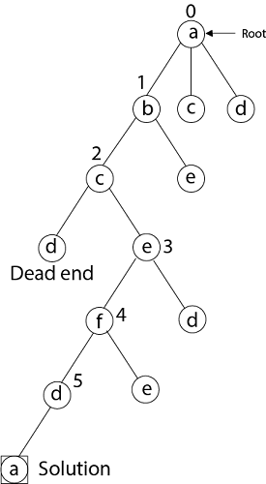
Here we have generated one Hamiltonian circuit, but another Hamiltonian circuit can also be obtained by considering another vertex.
Backtracking Algorithm for Hamilton circuit problem:
Create an empty path array and add vertex 0 to it. Add other vertices, starting from the vertex 1. Before adding a vertex, check for whether it is adjacent to the previously added vertex and not already added. If we find such a vertex, we add the vertex as part of the solution. If we do not find a vertex then we return false.
Implementation of Backtracking solution
Following are implementations of the Backtracking solution.
/* C program for solution of Hamiltonian Cycle problem
using backtracking */
#include<stdio.h>

// Number of vertices in the graph
#define V 5

voidprintSolution(intpath[]);

/* A utility function to check if the vertex v can be added at
index 'pos' in the Hamiltonian Cycle constructed so far (stored
in 'path[]') */
boolisSafe(intv, boolgraph[V][V], intpath[], intpos)
{
/* Check if this vertex is an adjacent vertex of the previously
added vertex. */
if(graph [ path[pos-1] ][ v ] == 0)
returnfalse;

/* Check if the vertex has already been included.
This step can be optimized by creating an array of size V */
for(inti = 0; i<pos; i++)
if(path[i] == v)
returnfalse;

returntrue;
}

/* A recursive utility function to solve hamiltonian cycle problem */
boolhamCycleUtil(boolgraph[V][V], intpath[], intpos)
{
/* base case: If all vertices are included in Hamiltonian Cycle */
if(pos == V)
{
// And if there is an edge from the last included vertex to the
// first vertex
if( graph[ path[pos-1] ][ path[0] ] == 1 )
returntrue;
else
returnfalse;
}

// Try different vertices as a next candidate in Hamiltonian Cycle.
// We don't try for 0 as we included 0 as starting point in hamCycle()
for(intv = 1; v < V; v++)
{
/* Check if this vertex can be added to Hamiltonian Cycle */
if(isSafe(v, graph, path, pos))
{
path[pos] = v;

/* recur to construct rest of the path */
if(hamCycleUtil (graph, path, pos+1) == true)
returntrue;

/* If adding vertex v doesn't lead to a solution,
then remove it */
path[pos] = -1;
}
}

/* If no vertex can be added to Hamiltonian Cycle constructed so far,
then return false */
returnfalse;
}

/* This function solves the Hamiltonian Cycle problem using Backtracking.
It mainly uses hamCycleUtil() to solve the problem. It returns false
if there is no Hamiltonian Cycle possible, otherwise return true and
prints the path. Please note that there may be more than one solutions,
this function prints one of the feasible solutions. */
boolhamCycle(boolgraph[V][V])
{
int*path = newint[V];
for(inti = 0; i< V; i++)
path[i] = -1;

/* Let us put vertex 0 as the first vertex in the path. If there is
a Hamiltonian Cycle, then the path can be started from any point
of the cycle as the graph is undirected */
path[0] = 0;
if( hamCycleUtil(graph, path, 1) == false)
{
printf("\nSolution does not exist");
returnfalse;
}

printSolution(path);
returntrue;
}

/* A utility function to print solution */
voidprintSolution(intpath[])
{
printf("Solution Exists:"
" Following is one Hamiltonian Cycle \n");
for(inti = 0; i< V; i++)
printf(" %d ", path[i]);

// Let us print the first vertex again to show the complete cycle
printf(" %d ", path[0]);
printf("\n");
}

// driver program to test above function
intmain()
{
/* Let us create the following graph
(0)--(1)--(2)
| / \ |
| / \ |
| / \ |
(3)-------(4) */
boolgraph1[V][V] = {{0, 1, 0, 1, 0},
{1, 0, 1, 1, 1},
{0, 1, 0, 0, 1},
{1, 1, 0, 0, 1},
{0, 1, 1, 1, 0},
};

// Print the solution
hamCycle(graph1);

/* Let us create the following graph
(0)--(1)--(2)
| / \ |
| / \ |
| / \ |
(3) (4) */
boolgraph2[V][V] = {{0, 1, 0, 1, 0},
{1, 0, 1, 1, 1},
{0, 1, 0, 0, 1},
{1, 1, 0, 0, 0},
{0, 1, 1, 0, 0},
};

// Print the solution
hamCycle(graph2);

return0;
}
Output:
Solution Exists: Following is one Hamiltonian Cycle
0 1 2 4 3 0

Solution does not exist
Note that the above code always prints a cycle starting from 0. The starting point should not matter as the cycle can be started from any point. If you want to change the starting point, you should make two changes to the above code.
Change “path[0] = 0;” to “path[0] = s;” where s is your new starting point. Also change loop “for (int v = 1; v < V; v++)” in hamCycleUtil() to “for (int v = 0; v < V; v++)”.
Please write comments if you find anything incorrect, or you want to share more information about the topic discussed above.

Graph Coloring Problem in Backtracking:
Given an undirected graph and a number m, determine if the graph can be coloured with at most m colours such that no two adjacent vertices of the graph are colored with the same color. Here coloring of a graph means the assignment of colors to all vertices.
Input-Output format:
Input:
- A 2D array graph[V][V] where V is the number of vertices in graph and graph[V][V] is an adjacency matrix representation of the graph. A value graph[i][j] is 1 if there is a direct edge from i to j, otherwise graph[i][j] is 0.
- An integer m is the maximum number of colors that can be used.
Output:
An array color[V] that should have numbers from 1 to m. color[i] should represent the color assigned to the ith vertex. The code should also return false if the graph cannot be colored with m colors.
Example:
Input:
graph = {0, 1, 1, 1},
{1, 0, 1, 0},
{1, 1, 0, 1},
{1, 0, 1, 0}
Output:
Solution Exists:
Following are the assigned colors
1 2 3 2
Explanation: By coloring the vertices
with following colors, adjacent
vertices does not have same colors

Input:
graph = {1, 1, 1, 1},
{1, 1, 1, 1},
{1, 1, 1, 1},
{1, 1, 1, 1}
Output: Solution does not exist.
Explanation: No solution exits.

Method:
Approach: The idea is to assign colors one by one to different vertices, starting from the vertex 0. Before assigning a color, check for safety by considering already assigned colors to the adjacent vertices i.e check if the adjacent vertices have the same color or not. If there is any color assignment that does not violate the conditions, mark the color assignment as part of the solution. If no assignment of color is possible then backtrack and return false.
Algorithm:
- Create a recursive function that takes the graph, current index, number of vertices, and output color array.
- If the current index is equal to the number of vertices. Print the color configuration in output array.
- Assign a color to a vertex (1 to m).
- For every assigned color, check if the configuration is safe, (i.e. check if the adjacent vertices do not have the same color) recursively call the function with next index and number of vertices
- If any recursive function returns true break the loop and return true.
- If no recursive function returns true then return false.

Below is the implementation of the above idea:
#include <stdbool.h>
#include <stdio.h>

// Number of vertices in the graph
#define V 4

voidprintSolution(intcolor[]);

/* A utility function to check if
the current color assignment
is safe for vertex v i.e. checks
whether the edge exists or not
(i.e, graph[v][i]==1). If exist
then checks whether the color to
be filled in the new vertex(c is
sent in the parameter) is already
used by its adjacent
vertices(i-->adj vertices) or
not (i.e, color[i]==c) */
boolisSafe(
intv, boolgraph[V][V],
intcolor[], intc)
{
for(inti = 0; i< V; i++)
if(
graph[v][i] && c == color[i])
returnfalse;
returntrue;
}

/* A recursive utility function
to solve m coloring problem */
boolgraphColoringUtil(
boolgraph[V][V], intm,
intcolor[], intv)
{
/* base case: If all vertices are
assigned a color then return true */
if(v == V)
returntrue;

/* Consider this vertex v and
try different colors */
for(intc = 1; c <= m; c++) {
/* Check if assignment of color
c to v is fine*/
if(isSafe(
v, graph, color, c)) {
color[v] = c;

/* recur to assign colors to
rest of the vertices */
if(
graphColoringUtil(
graph, m, color, v + 1)
== true)
returntrue;

/* If assigning color c doesn't
lead to a solution then remove it */
color[v] = 0;
}
}

/* If no color can be assigned to
this vertex then return false */
returnfalse;
}

/* This function solves the m Coloring
problem using Backtracking. It mainly
uses graphColoringUtil() to solve the
problem. It returns false if the m
colors cannot be assigned, otherwise
return true and prints assignments of
colors to all vertices. Please note
that there may be more than one solutions,
this function prints one of the
feasible solutions.*/
boolgraphColoring(
boolgraph[V][V], intm)
{
// Initialize all color values as 0.
// This initialization is needed
// correct functioning of isSafe()
intcolor[V];
for(inti = 0; i< V; i++)
color[i] = 0;

// Call graphColoringUtil() for vertex 0
if(
graphColoringUtil(
graph, m, color, 0)
== false) {
printf("Solution does not exist");
returnfalse;
}

// Print the solution
printSolution(color);
returntrue;
}

/* A utility function to print solution */
voidprintSolution(intcolor[])
{
printf(
"Solution Exists:"
" Following are the assigned colors \n");
for(inti = 0; i< V; i++)
printf(" %d ", color[i]);
printf("\n");
}

// driver program to test above function
intmain()
{
/* Create following graph and test
whether it is 3 colorable
(3)---(2)
| / |
| / |
| / |
(0)---(1)
*/
boolgraph[V][V] = {
{ 0, 1, 1, 1 },
{ 1, 0, 1, 0 },
{ 1, 1, 0, 1 },
{ 1, 0, 1, 0 },
};
intm = 3; // Number of colors
graphColoring(graph, m);
return0;
}
Output
Solution Exists: Following are the assigned colors
1 2 3 2
Complexity Analysis:
- Time Complexity: O(m^V).
There are total O(m^V) combination of colors. So time complexity is O(m^V). The upperbound time complexity remains the same but the average time taken will be less.
- Space Complexity: O(V).
Recursive Stack of graphColoring(…) function will require O(V) space.

Sum of Subset Problem:
It is one of the most important problems in complexity theory. The problem is given an A set of integers a1, a2,…., an upto n integers. The question arises that is there a non-empty subset such that the sum of the subset is given as M integer?. For example, the set is given as [5, 2, 1, 3, 9], and the sum of the subset is 9; the answer is YES as the sum of the subset [5, 3, 1] is equal to 9. This is an NP-complete problem again. It is the special case of knapsack

Let's understand this problem through an example.
problem.
We have a set of 5 integers given below:
N = 4, -2, 2, 3, 1
We want to find out the subset whose sum is equal to 5. There are many solutions to this problem.
The naïve approach, i.e., brute-force search generates all the possible subsets of the original array, i.e., there are 2n possible states. Here the running time complexity would be exponential. Then, we consider all these subsets in O(N) linear running time and checks whether the sum of the items is M or not.
The dynamic programming has pseudo-polynomial running time.
Statement: Given a set of positive integers, and a value sum, determine that the sum of the subset of a given set is equal to the given sum.
Or
Given an array of integers and a sum, the task is to have all subsets of given array with sum equal to the given sum.
- Example 1:
- Input: set[] = {4, 16, 5, 23, 12}, sum = 9
- Output = true
- Subset {4, 5} has the sum equal to 9.

- Example 2:
- Input: set[] = {2, 3, 5, 6, 8, 10}, sum = 10
- Output = true
- There are three possible subsets that have the sum equal to 10.
- Subset1: {5, 2, 3}
- Subset2: {2, 8}
- Subset3: {10}
There are two ways of solving the subset problem:
- Recursion
- Dynamic programming
Method 1: Recursion
Before knowing about the recursive approach, we should know about two things in a subset which are given below:
- Include: Here include means that we are selecting the element from the array.
- Exclude: Here, exclude means that we are rejecting the element from the array.
To implement the recursive approach, we consider the following two cases:
- Now we consider the first element and now the required sum is equal to the difference between the target sum and value of first element. The number of elements is equal to the difference between the total elements and 1.
- Leave the 'first' element and now the required sum = target sum. The number of elements is equal to the difference between the total elements and 1.
Let's understand that how can we solve the problem using recursion. Consider the array which is given below:
arr = [3, 4, 5, 2]
sum = 9
result = []
In the above example, we have taken an array, and the empty array named result that stores all the values whose resultant sum is equal to 9.
First element in an array is 3. There are two scenarios:
- First scenario is select. The sum is equal to the target sum - value of first element, i.e., 9 - 3 = 6 and the first element, i.e., 3 gets stored in the result array, i.e., result[].
- Second scenario is reject. The array arr contains the elements 4, 5, 2, i.e., arr = [4, 5, 2] and sum would be same as 9 as we are rejecting the element 3. The result[] array would remain empty.

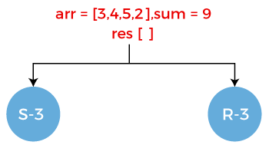
- Now we perform the same select and reject operation on element 4 as it is the first element of the array now.
- Select the element 4 from the array. Since we are selecting 4 from the array so array arr would contain the elements 5, 2, i.e., arr = [5, 2]. The sum is equal to the 6-4 = 2 and the element 4 gets stored in the result arr. The result[] = {3, 4}.
- Reject the element 4 from the array. Since we are rejecting the 4 from the array so array arr would contain the elements 5, 2, i.e., arr = [5, 2]. The sum would remain same as 6 and the result array would be same as previous, i.e., {3}.
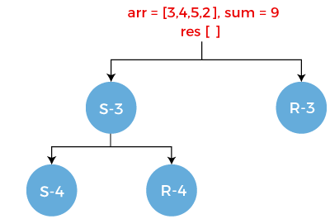
- Now we perform the select and reject operation on element 5.
- Select the element 5 from the array. Since we are selecting 5 from the array so array arr would contain the elements 2, i.e., arr = [2]. The sum is equal to the 2 - 5 equals to -3 and the element 5 gets stored in the result arr. The result[] = {3, 4, 5}.
- Reject the element 5 from the array. Since we are rejecting 5 from the array so array arr would contain the element 2, i.e., arr = [2]. The sum would remain same as previous, i.e., 6 and the result array would be same as previous, i.e., {3, 4}.
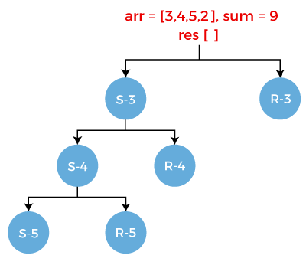
If we observe S-5, we can see that the sum is negative that returns false. It means that there is no further subset available in the set.
Consider R-5. It also has two scenarios:
- Select the element 2 from the array. Once the element 2 gets selected, the array becomes empty, i.e., arr[] = " ". The sum would be 2-2 equals to 0 and the element 2 gets stored in the result array. The result[] = [3, 4, 2].
- Reject the element 2 from the array. Once the element 2 gets rejected, the array becomes empty, i.e., arr[] = " ". The sum would be same as previous, i.e., 2 and the result array would also be same as previous, i.e., [3, 4].
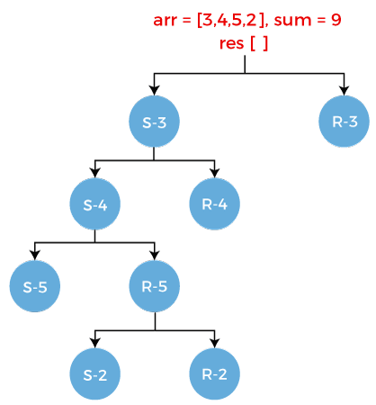
Consider R-4. It has two scenarios:
- Select the element 5 from the array. Since we are selecting 5 from the array so array arr would contain the elements 2, i.e., arr = [2]. The sum would be 6-5 equals to 1 and the element 5 gets stored in the result array. The result[] = [3, 5].
- Reject the element 5 from the array. Since we are rejecting 5 from the array so array arr would contain the element 2, i.e., arr = [2]. The sum would remain same as previous, i.e., 6 and the result array would be same as previous, i.e., {3}.
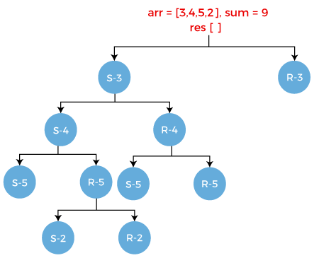
Consider S-5. It has two scenarios:
- Select the element 2 from the array. Since we are selecting 2 from the array so array arr would be empty, i.e., arr = " ". The sum would be 1-2 equals to -1 and the element 2 gets stored in the result array. The result[] = [3, 5, 2].
- Reject the element 2 from the array. Since we are rejecting 2 from the array so array arr would become empty. The sum would remain same as previous, i.e., 1 and the result array would be same as previous, i.e., {3, 5}.
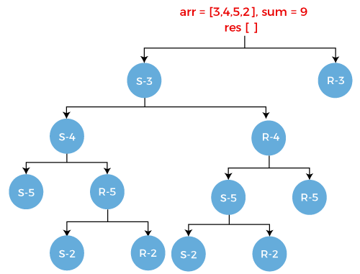
Consider R-5. It has two scenarios:
- Select the element 2 from the array. Since we are selecting 2 from the array so array arr would be empty, i.e., arr = " ". The sum would be 6-2 equals to 4 and the element 2 gets stored in the result array. The result[] = [3, 2].
- Reject the element 2 from the array. Since we are rejecting 2 from the array so array arr would become empty. The sum would remain same as previous, i.e., 6 and the result array would be same as previous, i.e., {3}.
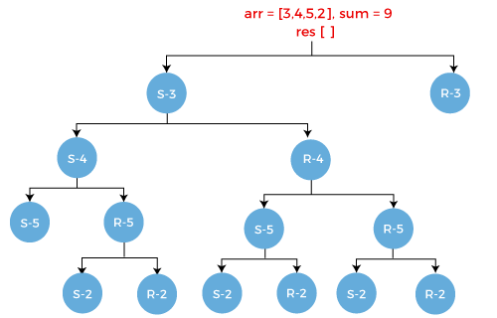
Similarly, we get the reject case, i.e., R-3 as shown as below:
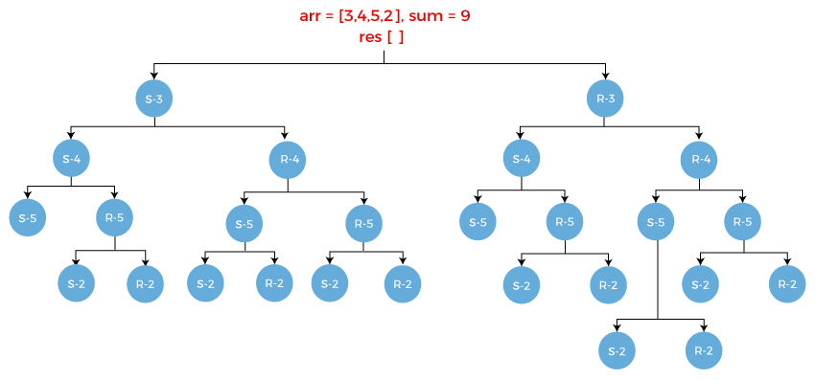
Following are the base conditions:
- if sum == 0
- return true
- if sum < 0
- return false
- if (arr[] && sum!= 0)
- return false
When we apply the base conditions on the above tree, then we will find two subsets given below:
S1 = {3, 4, 2}
S2 = {4, 5}
Implementation
- def subset_sum(arr, res, sum)
- if sum ==0
- return true
- if sum < 0
- return false
- if len(arr) == 0 and sum!= 0
- return false
- arr.pop(0);
- if len(arr) > 0
- res.append(arr[0])
- select = subset_sum(arr, sum-arr[0], res)
- reject = subset_sum(arr, res, sum)
- return reject or sum
Method 2: Dynamic Programming
Let A be an array or set which contains 'n' non-negative integers. Find a subset 'x' of set 'A' such that the sum of all the elements of x is equal to w where x is another input (sum).
For example:
A = {1, 2, 5, 9, 4}
Sum(w) = 18
Now we have to find out the subset from the given set whose sum is equal to 18. Here we will use the dynamic programming approach to solve the subset sum problem.
Example:
A = [2, 3, 5, 7, 10]
Sum(w) = 14
First, we create a table. The column contains the values from 0 to 14 while row contains the elements of the given set shown as below:
In the below table:
i: It represents the rows. Rows represents the elements.
j: It represents the columns. Columns represent the sum.
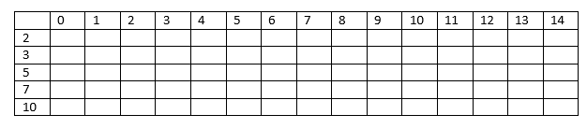
Consider the element 2. We will use 1 as a true value and 0 as a false value. The value 1 comes under 0 and 2 columns shown as below:
Here i=1, a[i] =2
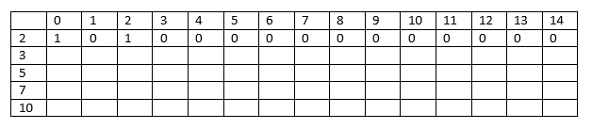
Note: The rule for filling each column is given below:
Required sum = j - element
A[i][j] = A[i-1][required sum]

When j= 1
Required sum = 1 - 2 = -1; Since the sum is negative so put 0 under the column 1 as shown in the above table.
When j= 2
Required sum = 2 - 2 = 0; Since the value of sum is zero so we put 1 under the column 2 as shown in the above table.
We put 0 under the columns whose sum is greater than 2 as we cannot make sum more than 2 from the element 2.
Consider the element 3.
Here i = 2, a[i] = 3
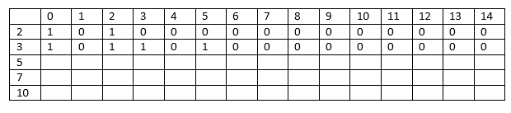
The columns whose sum is less than 3 will have the same values as the previous columns.
When j = 3, sum[j] = 3
Required sum = 3 -3 = 0; since the sum is zero so we put 1 under the column 3 as shown in the above table.
When j = 4; sum[j] = 4
Required sum = 4 - 3 = 1; Since the sum is 1 so we move to the previous row, i.e., i=1 and j=1. The value at a[1][1] is 0 so we put 0 at a[2][4].
When j = 5, sum[j] = 5
Required sum = 5 -3 = 2; The value of sum is 2 so the value at a[1][2] equals to 1. Therefore, the value at a[2][5] would be 1.
When j = 6, sum[j] = 6
Required sum = 6 -3 = 3; The value of sum is 3 so the value at a[1][3] equals to 0. Therefore, the value at a[2][6] would be 0.
When j = 7, sum[7] = 7
Required sum = 7 - 3 = 4; The value of sum is 4 so the value at a[1][4] equals to 0. Therefore, the value at a[2][7] would be 0.
In this way, we get the value 0 from the columns 8 to 14.
Consider the element 5.
Here i=3, a[i] = 5
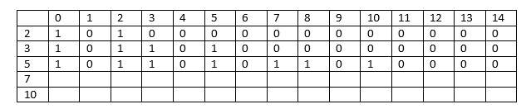
The columns whose sum is less than 5 will have the same values as the previous columns.
When j =5, sum[j] = 5
Required sum = 5-5 = 0; Since the value of sum is 0; therefore, the value at a[2][5] equals to 1.
When j = 6, sum[j] = 6
Required sum = 6-5 = 1; the value of sum is 1 so the value at a[2][1] equals to 0; therefore, the value at a[3][6] equals to 0.
When j=7, sum[j] = 7
Required sum = 7-5 = 2; the value of sum is 2 so the value at a[2][2] equals to 1; therefore, the value at a[3][7] equals to 1.
When j=8, sum[j] = 8
Required sum = 8-5 = 3; the value of sum is 3 so the value at a[2][3] equals to 1; therefore, the value at a[3][8] equals to 1.
When j=9, sum[j] =9
Required sum= 9-5 = 4; the value of sum is 4 so the value at a[2][4] equals to 0; therefore the value at a[3][9] equals to 0.
In this way, we get the values from the columns 10 to 14.
Consider the element 7.
Here i=4, a[i] =7
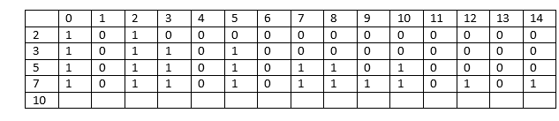
The columns whose sum is less than 7 will have the same values as the previous columns.
When j=9, sum[j] = 9
Required sum = 9 - 7 = 2; the value of sum is 2 so the value at a[3][2] equals to 1; therefore the value at a[4][9] equals to 1.
When j=10, sum[j] = 10
Required sum = 10 - 7= 3; the value of sum is 3 so the value at a[3][3] equals to 1; therefore, the value at a[4][10] equals to 1.
When j=11, sum[j] =11
Required sum = 11-7 = 4; the value of sum is 4 so the value at a[3][4] equals to 0; therefore, the value at a[4][11] equals to 0.
When j=12, sum[j] = 12
Required sum = 12-7 = 5; the value of sum is 5 so the value at a[3][5] equals to 1; therefore, the value at a[4][12] equals to 1.
When j=13, sum[j] =13
Required sum= 13 - 7 = 6; the value of sum is 6 so the value at a[3][6] equals to 0; therefore, the value at a[4][13] equals to 0.
When j=14, sum[j] = 14
Required sum = 14 - 7 = 7; the value of sum is 7 so the value at a[3][7] equals to 1; therefore, the value at a[4][14] equals to 1.
Consider the element 10
Here i=5, a[i] = 10
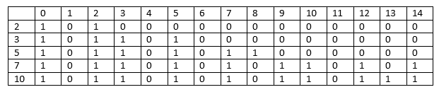
The columns whose sum is less than 10 will have the same values as the previous columns.
When j = 10, sum[j] = 10
Required sum = 10 - 10 = 0; the value of sum is 0 so the value at a[4][0] equals to 1; therefore, the value at a[5][10] equals to 1.
When j = 11, sum[j] = 11
Required sum = 11 - 10 = 1; the value of sum is 1 so the value at a[4][1] equals to 0; therefore, the value at a[5][11] equals to 0.
When j=12, sum[j] = 12
Required sum = 12-10 = 2; the value of sum is 2 so the value at a[4][2] equals to 1; therefore, the value at a[5][12] equals to 1.
When j=13, sum[j] = 13
Required sum = 13 - 10 = 3; the value of sum is 3 so the value at a[4][3] equals to 1; therefore, the value at a[5][13] equals to 1.
To determine whether the above given problem contains the subset or not, we need to check the last row and the last column. If the value is 1 which means that there would exist atleast one subset.
We have basically followed three conditions where we write 1 in the cell of the table:
• A[i] = j
• A[i-1][j] = 1
• A[i-1][j-A[i]] = 1

Subset Sum Problem:

Given a set of non-negative integers, and a value sum, determine if there is a subset of the given set with sum equal to given sum.
Example:
Input:set[] = {3, 34, 4, 12, 5, 2}, sum = 9
Output: True
There is a subset (4, 5) with sum 9.

Input:set[] = {3, 34, 4, 12, 5, 2}, sum = 30
Output: False
There is no subset that add up to 30.

Method 1: Recursion.
Approach: For the recursive approach we will consider two cases.
- Consider the last element and now the required sum = target sum – value of ‘last’ element and number of elements = total elements – 1
- Leave the ‘last’ element and now the required sum = target sum and number of elements = total elements – 1
Following is the recursive formula for isSubsetSum() problem.
isSubsetSum(set, n, sum)
= isSubsetSum(set, n-1, sum) ||
isSubsetSum(set, n-1, sum-set[n-1])
Base Cases:
isSubsetSum(set, n, sum) = false, if sum > 0 and n == 0
isSubsetSum(set, n, sum) = true, if sum == 0
Let’s take a look at the simulation of above approach-:
set[]={3, 4, 5, 2}
sum=9
(x, y)= 'x' is the left number of elements,
'y' is the required sum

(4, 9)
{True}
/ \
(3, 6) (3, 9)

/ \ / \
(2, 2) (2, 6) (2, 5) (2, 9)
{True}
/ \
(1, -3) (1, 2)
{False} {True}
/ \
(0, 0) (0, 2)
{True} {False}
// A recursive solution for subset sum problem
#include <stdio.h>

// Returns true if there is a subset
// of set[] with sum equal to given sum
boolisSubsetSum(intset[], intn, intsum)
{
// Base Cases
if(sum == 0)
returntrue;
if(n == 0)
returnfalse;

// If last element is greater than sum,
// then ignore it
if(set[n - 1] > sum)
returnisSubsetSum(set, n - 1, sum);

/* else, check if sum can be obtained by any
of the following:
(a) including the last element
(b) excluding the last element */
returnisSubsetSum(set, n - 1, sum)
|| isSubsetSum(set, n - 1, sum - set[n - 1]);
}

// Driver code
intmain()
{
intset[] = { 3, 34, 4, 12, 5, 2 };
intsum = 9;
intn = sizeof(set) / sizeof(set[0]);
if(isSubsetSum(set, n, sum) == true)
printf("Found a subset with given sum");
else
printf("No subset with given sum");
return0;
}
Output
Found a subset with given sum
Complexity Analysis: The above solution may try all subsets of given set in worst case. Therefore time complexity of the above solution is exponential. The problem is in-fact NP-Complete (There is no known polynomial time solution for this problem).

N-Queens Problem
N - Queens problem is to place n - queens in such a manner on an n x n chessboard that no queens attack each other by being in the same row, column or diagonal.
It can be seen that for n =1, the problem has a trivial solution, and no solution exists for n =2 and n =3. So first we will consider the 4 queens problem and then generate it to n - queens problem.
Given a 4 x 4 chessboard and number the rows and column of the chessboard 1 through 4.
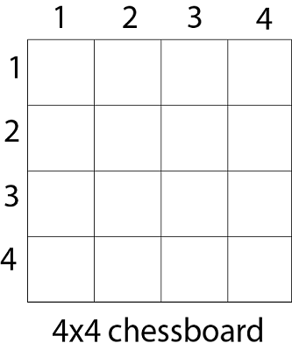
Since, we have to place 4 queens such as q₁ q₂ q₃ and q₄ on the chessboard, such that no two queens attack each other. In such a conditional each queen must be placed on a different row, i.e., we put queen "i" on row "i."
Now, we place queen q₁ in the very first acceptable position (1, 1). Next, we put queen q₂ so that both these queens do not attack each other. We find that if we place q₂ in column 1 and 2, then the dead end is encountered. Thus the first acceptable position for q₂ in column 3, i.e. (2, 3) but then no position is left for placing queen 'q₃' safely. So we backtrack one step and place the queen 'q₂' in (2, 4), the next best possible solution. Then we obtain the position for placing 'q₃' which is (3, 2). But later this position also leads to a dead end, and no place is found where 'q₄' can be placed safely. Then we have to backtrack till 'q₁' and place it to (1, 2) and then all other queens are placed safely by moving q₂ to (2, 4), q₃ to (3, 1) and q₄ to (4, 3). That is, we get the solution (2, 4, 1, 3). This is one possible solution for the 4-queens problem. For another possible solution, the whole method is repeated for all partial solutions. The other solutions for 4 - queens problems is (3, 1, 4, 2) i.e.
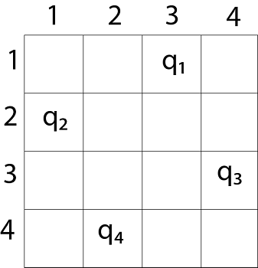
The implicit tree for 4 - queen problem for a solution (2, 4, 1, 3) is as follows:
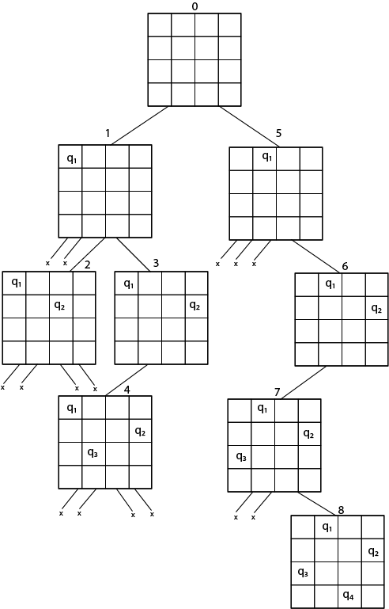
Fig shows the complete state space for 4 - queens problem. But we can use backtracking method to generate the necessary node and stop if the next node violates the rule, i.e., if two queens are attacking.
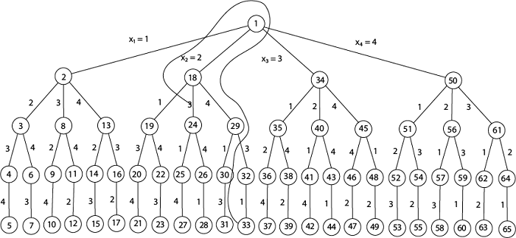
t can be seen that all the solutions to the 4 queens problem can be represented as 4 - tuples (x₁, x₂, x₃, x₄) where x_{i} represents the column on which queen "q_{i}" is placed.
One possible solution for 8 queens problem is shown in fig:
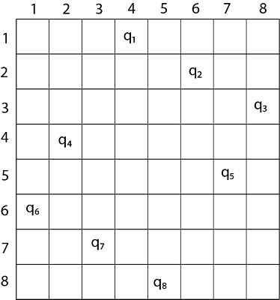
- Thus, the solution for 8 -queen problem for (4, 6, 8, 2, 7, 1, 3, 5).
- If two queens are placed at position (i, j) and (k, l).
- Then they are on same diagonal only if (i - j) = k - l or i + j = k + l.
- The first equation implies that j - l = i - k.
- The second equation implies that j - l = k - i.
- Therefore, two queens lie on the duplicate diagonal if and only if |j-l|=|i-k|

Place (k, i) returns a Boolean value that is true if the kth queen can be placed in column i. It tests both whether i is distinct from all previous costs x₁, x₂,....x_{k-1} and whether there is no other queen on the same diagonal.
Using place, we give a precise solution to then n- queens problem.
- Place (k, i)
- {
- For j ← 1 to k - 1
- do if (x [j] = i)
- or (Abs x [j]) - i) = (Abs (j - k))
- then return false;
- return true;
- }

Place (k, i) return true if a queen can be placed in the kth row and ith column otherwise return is false.
x [] is a global array whose final k - 1 values have been set. Abs (r) returns the absolute value of r.
- N - Queens (k, n)
- {
- For i ← 1 to n
- do if Place (k, i) then
- {
- x [k] ← i;
- if (k ==n) then
- write (x [1....n));
- else
- N - Queens (k + 1, n);
- }
- }

